**Pre-Assigning Breakout Rooms For Discussion**

All of the information in this file can be found [here](https://support.zoom.us/hc/en-us/articles/206476093) and [here](https://support.zoom.us/hc/en-us/articles/360032752671-Pre-assigning-participants-to-breakout-rooms#h_f1d7287d-ade8-4b73-b0b9-37365faecf55). The former has a nice video. This document mostly exists to provide helpful screenshots.

Allowing breakout rooms when scheduling

* Start the Zoom application and sign in with your UMN account.
* A screenshot of a cell phone

  Description automatically generatedGo to the “Settings” tab.
* Go to “In Meeting (Advanced)”

* A screenshot of a cell phone

  Description automatically generatedMake sure “Breakout Room” is enabled (toggle switch right), then check “Allow host to assign participants to breakout rooms when scheduling”. Click “Save” so that your settings are saved.
* Now you will be able to pre-assign breakout rooms when scheduling a meeting. These will be based on participant email addresses.

Pre-assigning Breakout Rooms

* Go to the “Meetings” tab.

* 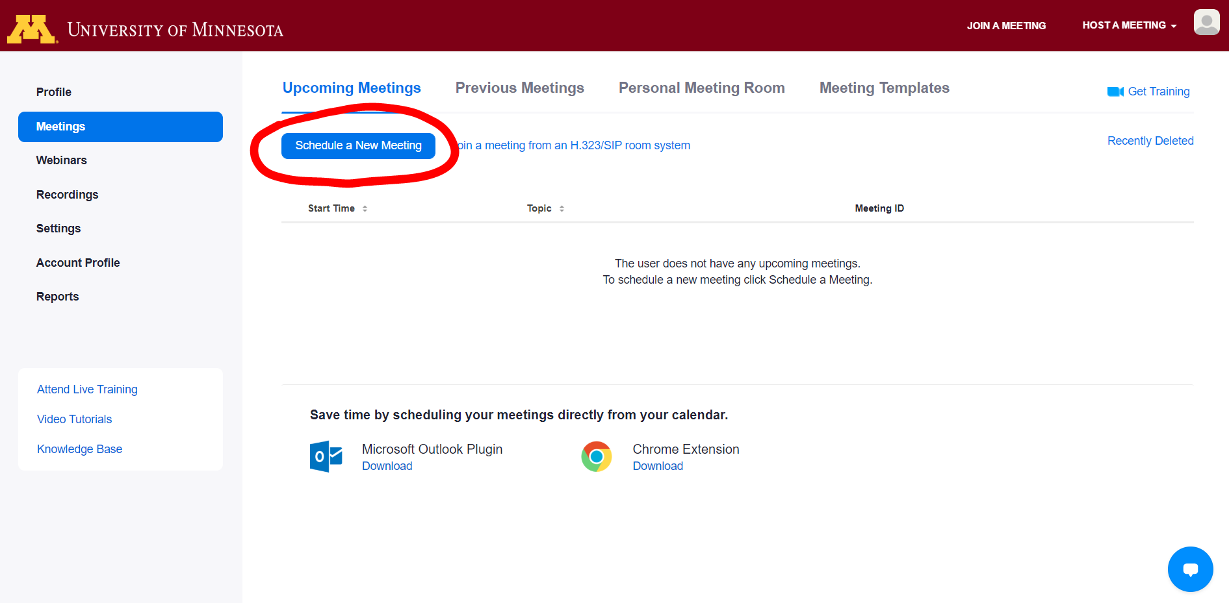Click “Schedule a Meeting”
* While not necessary to pre-assigning participants, you may create a recurring meeting by checking the “Recurring meeting” box.
  + Breakout room assignments will persist for recurring meetings – this is helpful so that you do not have to reassign the same groups every week.
  + You may choose the recurrence period – for discussions one would choose “Weekly” recurrence, and then repeat 1 time weekly on the discussion day.
  + A screenshot of a cell phone

    Description automatically generatedYou may also choose to end the scheduled meetings on a certain date – presumably, this would be the end of the semester.
* 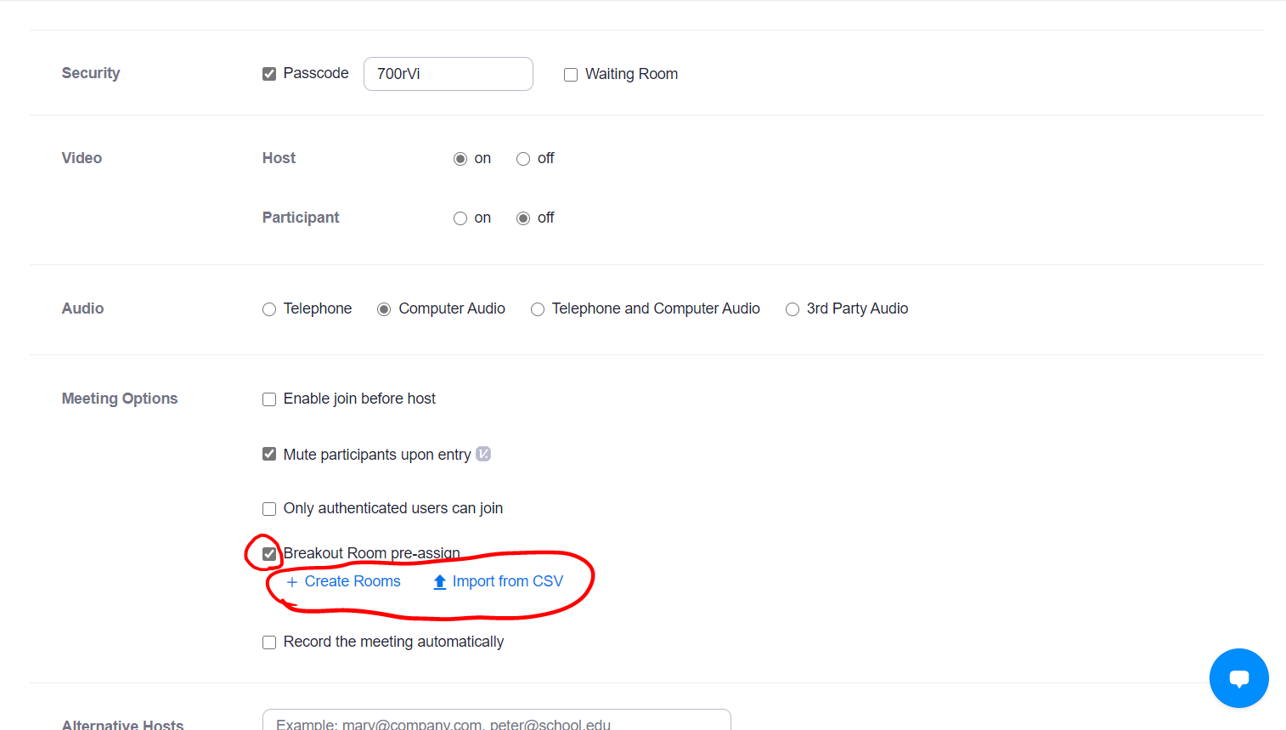Scroll down to “Meeting Options” and check the “Breakout Room pre-assign” box. Click either “Create Rooms” or “Import from CSV” depending on how you would like to assign breakout rooms.

Create Rooms

* If you clicked “Create Rooms”, a popup titled “Breakout Room Assignment” should come up.
  + To Add breakout rooms, click the “+” button.
  + To assign participants, enter their email into the “Add Participants” box.
  + A screenshot of a cell phone

    Description automatically generatedTo rename breakout rooms, click on them in the “Rooms” tab, then click the title in the right box.
  + Click “Save” when you are finished.

Import From CSV

* In order to import breakout rooms from a .csv file, you need to download [this sample csv file](https://support.zoom.us/hc/en-us/article_attachments/360051832571/breakout_room_sample.csv).
  + This file has two columns. The left column is which breakout room the participant in that row will be put in. These are labeled with the convention “room#” where you would put the room number in place of #.
  + A screenshot of a cell phone

    Description automatically generatedThe second column contains the email address of the assigned participant.
* Finally, click “Save” at the bottom to create the meeting.

Only allow authenticated users

* To make sure that students are signed into their school emails, and will therefore be automatically assigned to the appropriate breakout room, you must enable the “Only authenticated users can join” option.
  + This will prompt the students to sign in when they try to join, if they are not already signed in.

Editing Breakout Room Assignments

* To edit your breakout room assignments, go to the “Meetings” tab in the Zoom app.
* Click which meeting you would like to edit.

* A screenshot of a cell phone

  Description automatically generatedScroll to the bottom and click “Edit this Meeting”
* If the meeting that you chose is part of a recurring meeting series, a prompt titled “Edit Meeting” should come up.
  + Here you can choose to either just edit this instance, or all the recurring meetings.
  + For the change to actually have an effect, **you must choose all**, otherwise your edits will not be saved, even if you click “Save”
* Then, you scroll down to the “Breakout Room pre-assign” checkbox as you did when first assigning breakout rooms.
  + There should be an “Edit” button this time. Click it, and then the steps to assign new breakout rooms are the same as before.